US HWY 41
RADIANT
WELLEN PARK BLVD.
MARKET WAY
SPRINGDALE

Grand Lake

KEY

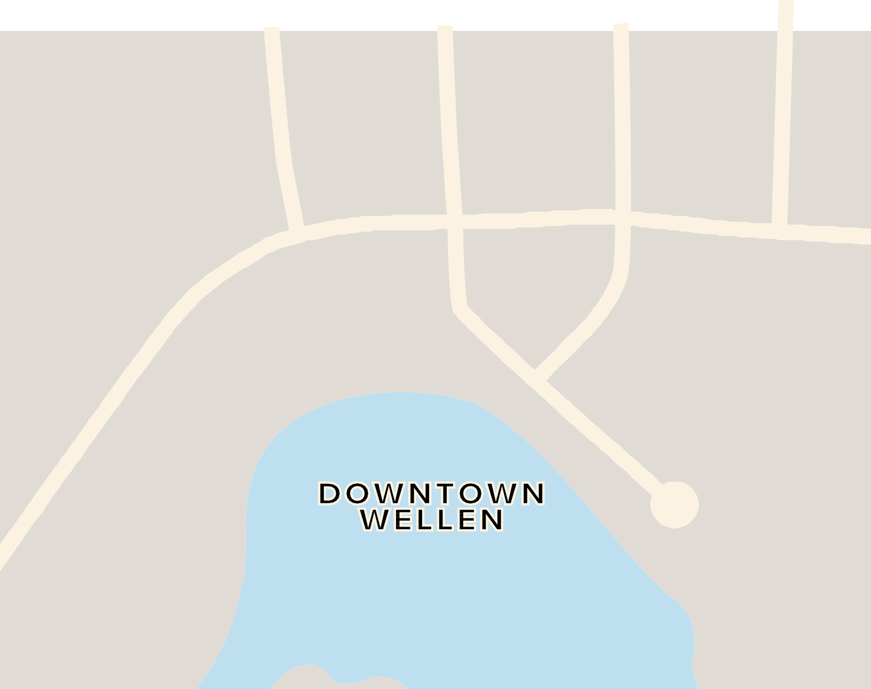





WELLEN PARK BLVD.
PRETO BLVD
SUNGLOW

LIGHT UP

WELLEN
OVERFLOW LOT HANDICAP LOT RSVP LOTS
POLICE CHECK POINT EVENT

